Sagard the Barbarian

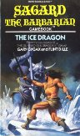  The Ice Dragon | 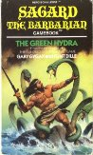  The Green Hydra | 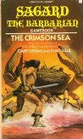  The Crimson Sea | 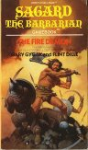  The Fire Demon
Sagard the Barbarian is a good gamebook series that serves as an excellent introduction to anyone not familiar with gamebooks or pen & paper RPGs in general. From Demian Katz' overview: "...this series of four books was released by Archway paperbacks in 1985 and 1986. The books were co-written by Gary Gygax, one of the creators of Dungeons & Dragons, and they featured a rules system including hit points, experience points, inventory and combat. Randomization was achieved with a four-sided die or by flipping through the pages. As in the Lone Wolf books, character statistics were carried from book to book."
One thing I like about the series is that each book includes a neat non-RPG mini-game to add variety. These are typically short board games with specific rules you must follow. The books are also well-written - the authors make up for the low number of sections (120+ compared to 350+ for most other gamebooks) by a detailed and atmospheric narrative. Although the prose is sometimes sophomoric and clichéd, with a big-muscled-barbarian-seduced-by-nubile-women kind of plot (which probably can only be expected to a certain extent, since this was targeted at male teenagers), this is still a fun series that should please every RPG/gamebook fan... except anyone who dislikes frequent dice-rolling.

