Tomb King Rules

In huge construct ships of Obsidian rock, animated by terrible, dark magic, the Tomb Kings are taking to the seas. Undead legions spill forth from the ships, bent on destruction and death. Sailing from the shores of The Land of The Dead, the huge ships sail forth. Death will come swiftly to those who they find.

All normal rules for fleets apply to the Tomb King Fleet unless otherwise stated.

ADMIRAL AND WIZARD

The leader of a Tomb King fleet is a Tomb King. This character acts as an admiral. You must also choose a Liche Priest. This is your main spell caster, but also is responsible for animating the fleet. The ships are all constructs, immense Obsidian rocks carved to make hulls. These must be animated to allow them to function as ships.
Battle Honours are listed below.
Tomb King: 5
Liche Priest: 1
Liche High Priest: 2
Grand Hierophant: 3

Screaming Skull Canons and Catapults.

The Tomb Kings have worked out now how to fire Screaming Skulls not just by Catapult, which had a few down falls, but also by normal cannon. These skulls have the normal effect that cannon balls have, having the same range and modifiers. There is only the Admiral ship that has kept the catapults, mainly due to the sheer size of the craft allowed it. These Screaming Skull catapults work in the normal way as other canons.

Bone Ship
Move: 9” magic
Weapons: 12 Screaming Skull Cannons, firing in all directions, and 1 Screaming Skull catapult firing forwards.
Crew: 14
Points: 500
Battle Honours: 16
The Bone ship is the most immense ship in the fleet. It is made of huge amounts of Obsidian and bone, chained together and animated by its own cabal of Liche Priests inside its huge body. It moves with the magical energy used to create and sustain it. Due to its size, the Bone ship literally pushes lesser ships aside that are in its path, causing huge amounts of damage along the way. The prow is from the skull of a long dead, immense creature that once roamed the Old World. Only one of these skulls have ever been found, so there can only ever be one of these huge ships, much to the relief of the Old World. When it moves into contact with another ship, let the Bone ship model push the other ship aside, and leave it where it ends up, then roll to save against one Below the Water line damage. It is brimming with Skull cannons, and even has a Skull catapult aboard, as they had some spare room! Inside the bowels of the ship, are the Liche Priests. They keep the ship bound together, afloat and moving, but they can also regenerate damage to the ship. Like the regeneration beam of the Pyramid ship, on a roll of 5+, a target location is regenerated, taking away any damage. Unlike the Pyramid ship, this is localised within the ship, and it cannot affect any other ship in the fleet. Possibly one of the most devastating weapons of the Bone Ships arsenal is the Gaze of Nagash. An old spell made by the Lord of the Undead. It is fired out of the eyes of the great prow. This weapon does no damage to an enemy vessel, but instead attacks the crew. It fires at a range of 3”. One die is rolled to see how many crew are attacked. A roll of 1 means the spell has no effect. A die is rolled for each crew counter attacked. For each 1 rolled, a crew counter is lost, the crew having been disintegrated by the power of the spell. This has to be aimed in the normal way, if for instance another admiral ship is being attacked they must declare if they are firing forward or aft, and must be able to attack the crew. So, for instance, a Nautilus must have damage before it can be boarded, so it must also be damaged before this spell will have affect.

Pyramid Ship
Move: 6” magic
Weapons: 8 Screaming Skull Cannons, firing fore and broadside.
Crew: 5
Points: 220
Battle Honours: 6

The Pyramid on the Pyramid Ships is an attempt to copy the great Pyramid of Nagash in Khremi. It is constructed to focus the dark, necromantic energies the Liche Priests use. This allows the magician on board to re-roll a failed attempt at casting a spell. Due to the way it works, by building up energy for a pre-ordained purpose, it can’t react well to attack, so cannot be used for re-rolling a dis-spell. This ability is removed if any of the Pyramid takes damage, as it cannot channel the magic correctly. As a kick back of the magical energy being released, the ship that damaged the Pyramid instantly gets one attack die, aimed at a low section with no modifying due to range. This is to represent the release of the magical energies through the air. This is for any location for the Pyramid.
The Pyramid ship is also equipped with a special weapon. It is a regeneration beam. A shot of magical energy that regenerates an area of a ship, taking away any damage. On a roll of 5+, a location that has been damaged, not including location on fire, will be regenerated. If the location has multiple damage boxes, one damage marker is removed if the roll is successful. It has a range of 3” and can be fired in a 360° arc.

Shpynx Ship
Move: 6” Magic
Weapons: Eyes of the Sphinx firing forwards, and 3 Screaming Skull Cannons, firing broadside.
Crew: 3
Points: 300 for squadron of 3
Battle Honours: 3

The Eyes of the Sphinx is a special magical weapon. It is a beam of pure, necromantic energy that shoots outwards at a fantastic range. This uses the longer range finder, and has no saving modifier. It attacks with one die.

Scorpian Ship
Move: 6” magic
Weapons: One Scorpion Tail, able to hit within 2”, in a 360° arc.
Crew: 2
Points: 75
Battle Honours: 2

The huge scorpion tail on the aft of the ship whips out towards the enemy ship in range, hitting with one die. The damage and location are worked out in the normal way. The tail can also be used to repel boarders, as the tail whips down at the invading crew. It has a range of 2”, so the ships have to close with the enemy before it can strike.

Scarab
Move: 6 Magic
Weapons: One Scarab canon firing forward and one canon firing forward.
Crew: 2
Points: 75
Battle Honours: 3

The Scarab has a special weapon. This is a canon, with normal range, and normal modifiers. The shot though, is a special shot that explodes on impact, and let’s lose a swarm of insect Scarabs. These Scarabs can eat through wood, stone, metal, you name it. They spread through the ship like wild fire and eat everything they can. Each successful hit uses the Scarab marker, and this is then treated exactly the same as fire in the End Phase. A new roll table is provided below for this. Second hits to an area do not cause critical damage. The other canon works normally.

- The Scarabs die, their energy spent. Remove the Scarab marker. Replace with a damage marker.
- The Scarabs don’t spread, roll again next end phase.
- The Scarabs don’t spread, roll again next end phase.
- Scarabs spread forward. Place another scarab marker.
- Scarabs spread upwards. Place another Scarab marker.
- Scarabs spreads backwards. Place another scarab marker.

Crew

Skeletons
These are the normal crew type for all ships, and use the normal rules for a standard crew type.

Tomb Guard
These are highly trained, better equipped crew that can help lead a defence or boarding action. They give a +1 to all boarding actions. They cost 25 points each, and can go on any ship.

Usbhati
These are the elite warriors of the Tomb Kings and they give a +2 bonus to boarding actions, but they come as standard with the Tomb King, being his elite guard. They cannot be bought for the Ships of the Line, as they are a rare unit, so will always be aboard the ship with the Tomb King.

Losing the main wizard

Once main wizard is lost, each ship in the fleet gets D6 Below the Waterline hits. This shows the struggle that the ships have when the magic that animated them is lost.

TOMB KINGS FLEET

Admiral Ship

The fleet can only EVER have one admiral ship. This is where the admiral and main wizard will be. If you do not have one, they will be aboard the main Man O’ War.

Cost: 500 points per Bone Ship.
Men O’ War: 1+

The fleet must have at least one Pyramid Ship to be your Admiral’s Flagship.

For every Ship of the Line squadron you may have 1 Pyramid Ship.

Cost: 200 points per Pyramid Ship.
Ship of the Line Squadrons: 2+

At least one squadron of three Sphinx Ships.

Cost: 300 points per squadron of 3 Sphinx Ships

At least one squadron of three Scorpion Ships.

For every Pyramid Ship you may have 2 Scorpion Ship squadrons.
For every Pyramid Ship squadron you may have 1 Sphinx Ship squadron.
Cost: 150 points per squadron of 3 Scorpion Ships.

Independents: 0+

For every Ship of the Line squadron you may have 1 Scarab.

Cost: 50 points per Scarab.

Admiral / Wizard: 1

You must have one Tomb King to act as Admiral.

Admiral Cost: Free
Wizard Cost: 100 points for a Liche Priest
150 points for a Liche High Priest
200 points for a Grand Hierophant

Men O’ War Cards: 1+

Cost: 1st card free with the Admiral, subsequent cards cost 25 points

Tomb Kings Fleet

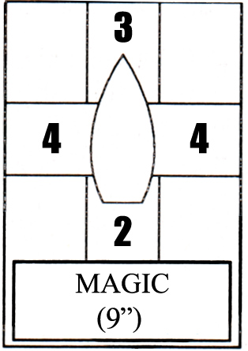
Bone Ship

Move:
Magic: 9” with the power of dark magic.
Can turn in place. Uses 100% of move per 90 degrees turn.

Weapons:
Screaming Skull Cannons. 2 Firing ahead, 2 rearward and 4 broadsides.
Screaming Skull Catapult. 1 firing forward

Special rules
Pushes aside ships when moving. Causes 1 below the waterline damage with normal save, and enemy ship is left to rest in new position.
Gaze of Nagash. Beam of Dark magic that attacks not the ship, but the crew. It has 3” range. Roll a die to see how many crew are attacked. Then one die is rolled to save per crew counter. Remove one crew counter for every 1 that is rolled.
Regeneration effect. Ship is able to regenerate one location per End Phase. Roll one Die, on a roll of 5 or 6, the location is healed.

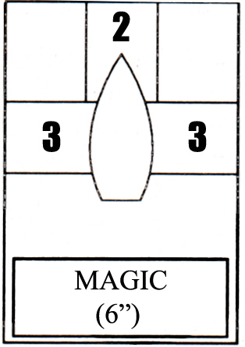
Pyrimid Ship

Move:
Magic: 6” with the power of dark magic.
Can turn in place. Uses 50% of move per 90 degrees turn.

Weapons:
2 Skull Cannons firing forward, and 3 Skull Cannons firing broadside.

Special Rules.
Regeneration Beam. Beam of Necromantic energy that repairs one location of friendly ship.
Must be within 3” of pyramid ship. Roll one Die, on a roll of 5 or 6, the location is healed.
Pyramid gives re-roll ability for wizard when casting spells. This is only when the main wizard is aboard this ship, and ability is taken away as soon as ANY damage occurs to the Pyramid locations.
Kick back effect shots out one hit towards low location of enemy ship that caused first damage to Pyramid.

Sphynx Ship
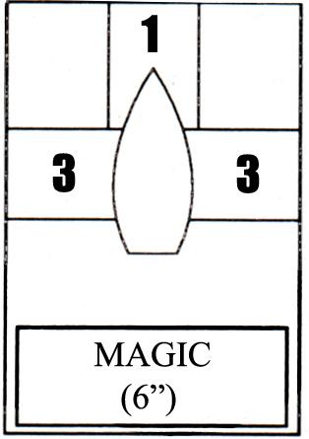
Move:
Magic: 6” with the power of dark magic.
Can turn in place. Uses 50% of move per 90 degrees turn.

Weapons:
3 Screaming Skull Cannons firing broadside.

Special Rules.
Eyes of the Sphinx firing forward, using larger firing template with no range modifier. Attacks with
1 die.

Scarab Ship
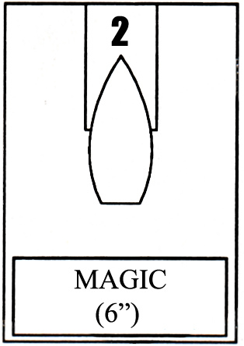
Move
Magic: 6” with the power of dark magic.
Can turn in place. Uses 50% of move per 90 degrees turn.

Weapons:
1 Scarab Cannon firing ahead.

Special Rules.
The weapon this ship fires is a small amount of Scarab Beatles that start to eat the structure of the enemy
vessel. They can eat anything, wood, metal, stone etc. They are treated the same as a
fire on the ship, that can spread, and leave damage on the vessel. Roll on table below in End Phase for any changes to Scarabs.

- The Scarabs die, their energy spent. Remove the Scarab marker, and replace with a damage marker.
- The Scarabs don’t spread, roll again next end phase.
- The Scarabs don’t spread, roll again next end phase.
- Scarabs spread forward. Place another scarab marker.
- Scarabs spread upwards. Place another Scarab marker.
- Scarabs spreads backwards. Place another scarab marker.

Scorpion/Snake Ship
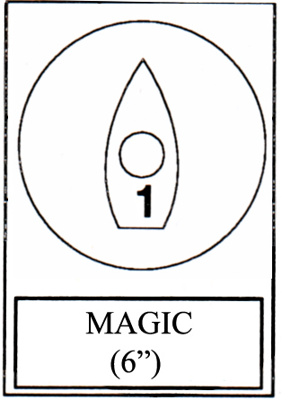
Move
Magic: 6” with the power of dark magic, and can move twice per turn.
Can turn in place. Uses 50% of move per 90 degrees turn.

Weapons:
One close quarters weapon, huge Scorpion tail attached to the aft of the ship that lashes out in 3” distance
from vessel. Hits with one die of power. Can also be used to repel boarders.

Q and A

Q - Did I get it correct, the screaming skull cannons have no crew effects?

A – Yes, the cannons used are normal cannons with normal cannon effect. This does not include the Screaming Skull Catapult on the Bone ship.

Q -What happens if the pyramid on the pyramid-ship is damaged
*by a spell? Kick-back over the whole seascape to the ship with the mage?
*by fire?
*by Ironfists, Nurgle Plaguecrushers, CD Great Leveller hitting it while floating protected behind other ships/terrain and firing other them, is then the first ship in line hit, regardless of Tomb King or enemy affiliation?

A – Spells and fire do not cause a kick back that would cause damage. The magic contained in the Pyramid is spread out over such a wide area that no ships would be damaged.
If the Pyramid if hit by a projectile fired from a ship behind another ship, the firing ship would still be attacked. The power of the Pyramid runs down the path the canon/rocket took through the air, hitting the ship that fired, not any inbetween.

