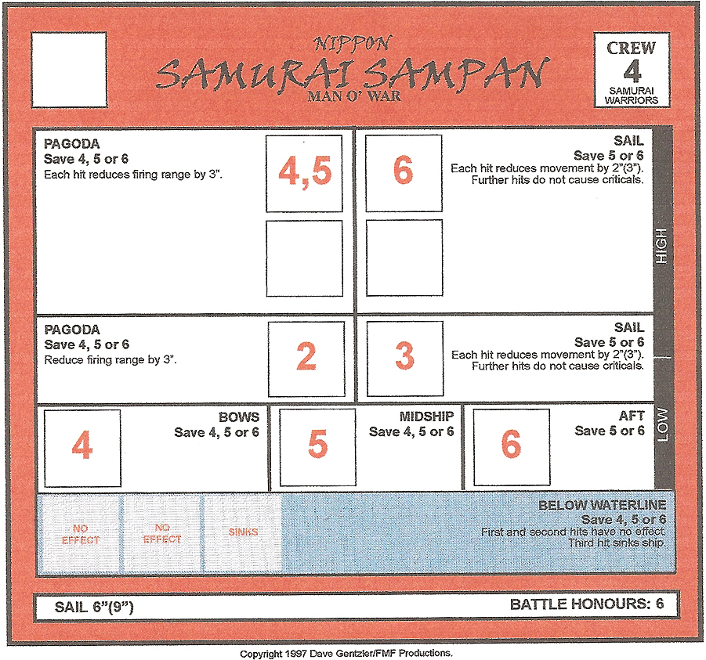

Samurai Sampan (MOW class: 150 Points)

Samurai Sampan are the floating battle platforms for those Nippon elite Samurai warriors who sail into combat for the Jade Emperor. The Sampan are elegantly crafted to reflect the proud heritage of the Nipponese people, the most prominent feature of each being the multi-tiered pagoda tower from which the Samurai fire their intricately carved, magical jade bows

Samurai Sampan have no permanent weapons onboard. Their firepower comes from the bow fire of the Samurai warriors that crew them. When you wish to fire using a Sampan, roll a number of dice equal to the number of crew aboard it. The Sampan has a 180 degree arc of fire to the front (the massive sail blocks rearward fire) and uses the Elf range template to determine whether the target is in range. There is no range modifier for shots fired from a Sampan. Roll to hit, declaring high or low as normal.

As the pagoda at the front of the ship takes damage, the Samurai retreat to the safety of the lower levels. This results in their bow fire losing the advantage of height and having a lesser range of fire. For each hit that the pagoda takes, the Samurai archers lose 3" of range. Note that even when the pagoda has been completely destroyed, the warriors still have a range of 3" as they stand on the ship's deck to fire.

As the Samurai aboard are killed in battle, their firepower is reduced as well. When rolling for a Sampan's attack, always roll a number of dice equal to the number of remaining Samurai warrior crew counters on the ship's template.

See the CREW notes for the Nippon fleet for important information regarding the Samurai warriors losing a boarding action.

