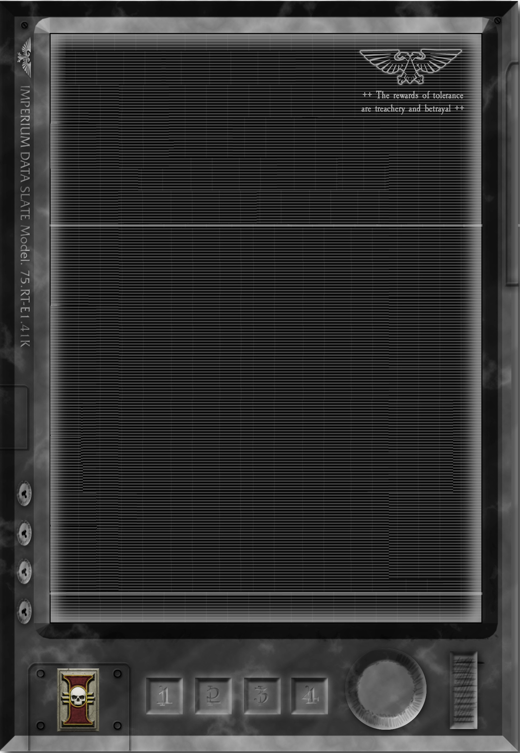
++Transmission++KAPPA LEVEL++
+Inquisitor Tigana Lys
+++ Quinton Duvalier+++
Greetings Quinton,

I have been reading each of your reports. In addition, I receive updates from my own alpha team. Each of my team are some of the best out there at what they specialize in, and it is my sincere hope that as you observe and learn from them in each of the training exercises that it will make you a better acolyte. To some, my choices and training methods may seem unorthodox, but I assure you I do have a plan.

Understand that in order for you to fully appreciate the training that I will be providing you each had to be torn down to your base elements. I needed a clean slate to mold and in order to accomplish this I had to have all of your pre-conceived notions and attitude stripped.

I want you to understand that I think you are doing well and I am impressed with the learning curve you are exhibiting. I would recommend you keep the morals you have learned from your lessons & trials close to you and always be prepared to build on them. Constantly learning is a key trait for one who served the Golden Throne, and a quality I am pleased that you seem to have embraced.

I assure you the matter with Cos-Carla has not been resolved, and this matter will be investigated further based on the reports received from my own Alpha Team, Raines, and yourself.

Sich zu irren, ist, zu sterben.

Inquisitor Tigana Lys

++End Transmission++

